

**Name : Sameer Kumar**

**Dept : Information Technology**

**Roll No : BIT-24S-005**

**Subject : Artificial Intelligence**

**(LAB TASKS)**

**LAB #01**

Q. MAKE 2 -2 PROGRAMS OF EACH DATA TYPE

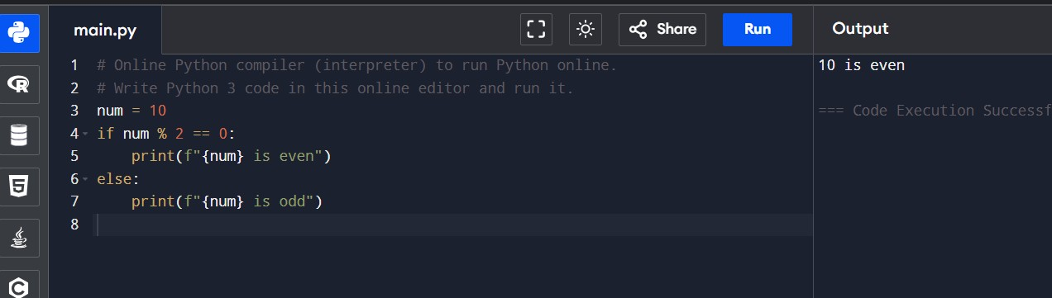

Q. MAKE UP TO 5 SHAPE PROGRAMS USING

Q. MAKE SAME SHAPES YOU HAVE MADE IN TASK 2 USING * MULTIPLE BY NUMBER

